***Computer Programming***

***CSL113***

***Assignment#1***



**Muhammad Saqib**

**01-134192-063**

**BSCS-1B**

**Department of Computer Science**

**BAHRIA UNIVERSITY, ISLAMABAD**

**Lab #: Lab Title**

**Objectives:**

**Tools Used:**

**Submission Date:**

**Evaluation: Signatures of Lab Engineer:**

**Task # 1:**

* **What does the following program print?**

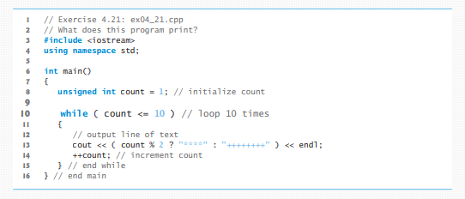

**Output:**

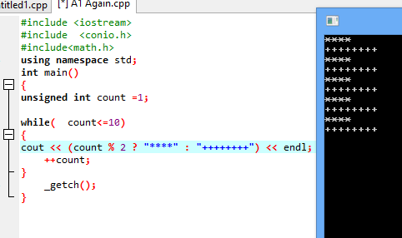

**Task#2:**

(Tabular Output) Write a C++ program that uses a while statement and the tab escape sequence \t to print the following table of values:

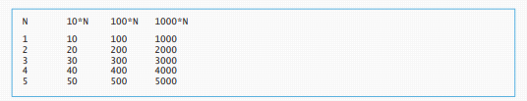

**Code&Output:**

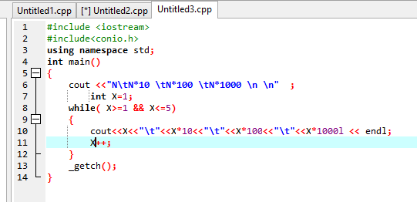

**Output:**

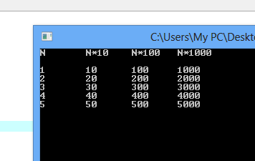

**Task#3:**

* Write a program for XYZ-Electric billing company. First understand the following situation. This program calculates a customer’s bill for XYZ-Electric billing company. There are two types of customers: residential and commercial. There are two rates for calculating a bill: one for residential customers and one for commercial customers.

For residential customers, the following rates apply:

• Bill processing fee: Rs.4.50/-

• Basic service fee: Rs.20.50/-

• Unit Rate: Rs.7.50 per Unit

For commercial customers, the following rates apply:

• Bill processing fee: Rs.10.50/-

• Basic service fee: Rs.50.50/-

• Unit Rate: Rs.12.50 per Unit The program should ask the user for an account number (an integer) and a customer code.

Assume that R or r stands for a residential customer, and C or c stands for a commercial customer

Input: The customer’s account number, customer code & number of units consumed for a particular month.

Output: Customer’s account number and the billing amount..

**Code:-**

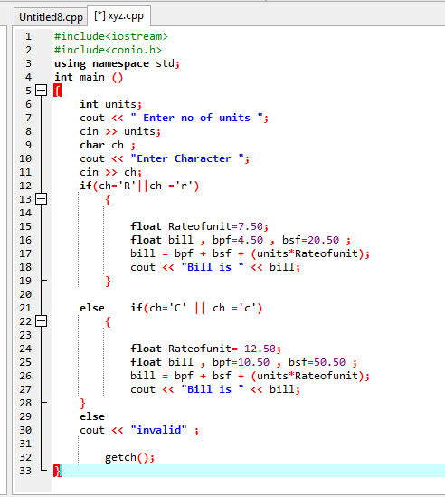

1. (**Find the Largest) The process of finding the largest number (i.e., the maximum of a group of numbers) is used frequently in computer applications. For example, a program that determines the winner of a sales contest inputs the number of units sold by each salesperson. The salesperson who sells the most units wins the contest. Write a C++ program that uses a while statement to determine and print the largest number of 10 numbers input by the user. Your program should use three variables, as follows:**

**counter: A counter to count to 10 (i.e., to keep track of how many numbers have been input and to determine when all 10 numbers have been processed) number:**

**The current number input to the program.**

**largest: The largest number found so far.**

**Output & Code:**

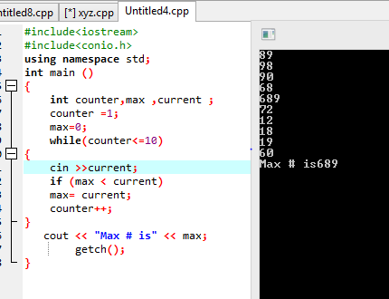

1. **5:-** Modify the following code to produce the output shown.

Use proper indentation techniques. You must not make any changes other than inserting braces. The Compiler ignores indentation in a C++ program. We eliminated the indentation from the following code to make the problem more challenging**. [Note: It’s possible that no modification is necessary.**

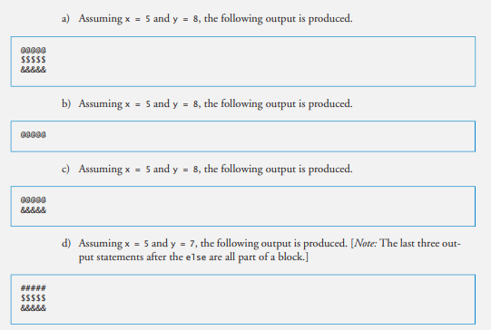

1. 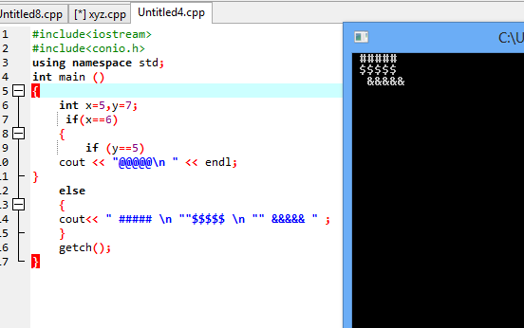
2. 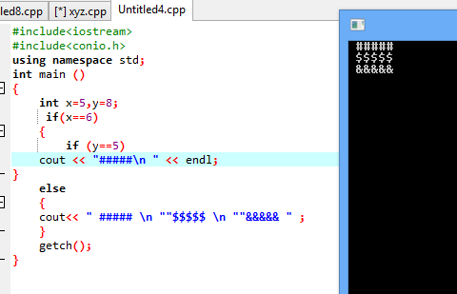

**C)hh**